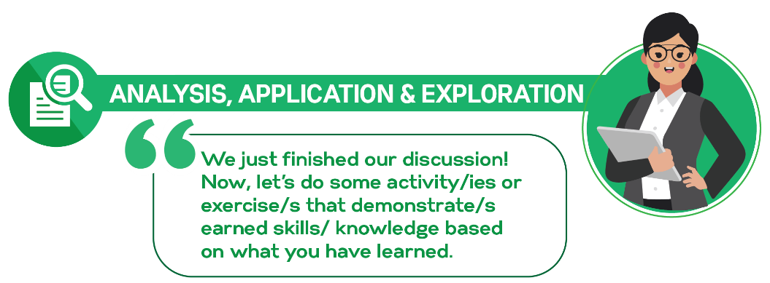

## ACTIVITY 1

Name: Parael, Shalomae G. Course & Section: BSIT-3113

**Instruction:** Based on what you have read, examine the following scenarios and give your answer in the space provided.

Hit and Run

Late one night you are driving home in a bad rainstorm. A drunk wanders out in front of your car and you try to stop, but hit him. Nobody sees you. You check to see how badly he is hurt and realize he is dead. You have never even had a speeding ticket and are an upright, professional, with a family and well-known and respected in your community. Do you make a report anonymously, confess your crime, or drive on home and forget about it, knowing no one is going to pursue the death of a homeless drunk? (Source: <https://icebreakerideas.com/moral-dilemma-questions/)>

ANSWER:

● For me, I will confess my crimes. The fact that it was an accident and didn’t meant to do it also its not only my fault hes at fault too because his drunk. I will face the consequences and punishment. I leave it to the judgement of the law of what his decision. I will accept and face the result because I know that I choose the right things to tell them the truth. And I don’t think my conscience will let me live if I leave him just like that. Always remember that truth is always prevail.

When making a purchase at a supermarket store, you are given too much change. Do you say something or be quiet?

ANSWER:

● I will tell them the truth that they give too much to me because I think it is the best things to do and also being dishonest not helps me to build up my morality. Being honest and telling the truth is always morally good and right.

Your neighbor leaves their dog out in all kinds of weather. The poor animal frequently looks like it is miserable. Sometimes, it is out of water and seems to be rarely fed. Do you report what you think is happening or stay quiet?

ANSWER:

● For me I will be quiet not because I don’t have care the animals, but because I don’t want to involve a problems from them. But I will come up with different way or solution like I will quietly feed the dog, give it a water to drink so it will helps to lessen the difficulty.

A friend gives you a gift for your birthday. Unfortunately, it is a type of perfume you are extremely allergic to. Do you say something and ask for a receipt to return it, or keep quiet?

ANSWER:

● For my side, I would gladly accept the gift even I’m allergic to a perfume. I would choose to be quiet because I don’t want to hurt his feelings because I know that he work hard for it, I would appreciate it and thanks him. You are very bless if you have a friends that generous to you.

You are failing a class you were required to take but totally hate. You have an online exam. If you fail the exam, you will fail the class. You can cheat without anyone knowing. Do you do so to pass the class?

ANSWER:

● I will not going to cheat even I will got a lower score or failed the exam. It is the best thing to do. Yes, I may be have a hard time to pass the exam but it doesn’t mean I’ll fail of course I will study hard and did my best to pass the exam.

## ACTIVITY 2

Name: Parael, Shalomae G. Course & Section: BSIT-313

**VENN DIAGRAM**

**Instruction**: Using a Venn diagram below, identify the differences and similarities of Moral and Non-Moral Standards. List down at least 3 examples of each standard.

involved the rules of people have

about the kinds of actions

They believe are morally right and wrong.________________i=______________________i__ They are both values

__________ T

**Ttttt r**efers to the rules that are unrelated to moral ethical

Considerations.

**Moral Standard**

**Non-Moral Standard**

**Similarity**

Examples

|  |  |
| --- | --- |
| Moral Standard | Non-Moral Standard |
| 1. Saying please to someone who you ask a favor or request | 1.Cheating |
| 1. Always tell the truth | 1. Steal the things of others |
| 1. Do not cheat | 1. Saying bad words |